NEW RULES FOR PENALTIES
There is now the possibility of penalizing a coach or the parent of a child competing in an event.
By Dick Rose 3 April 2017 at 1:31pm

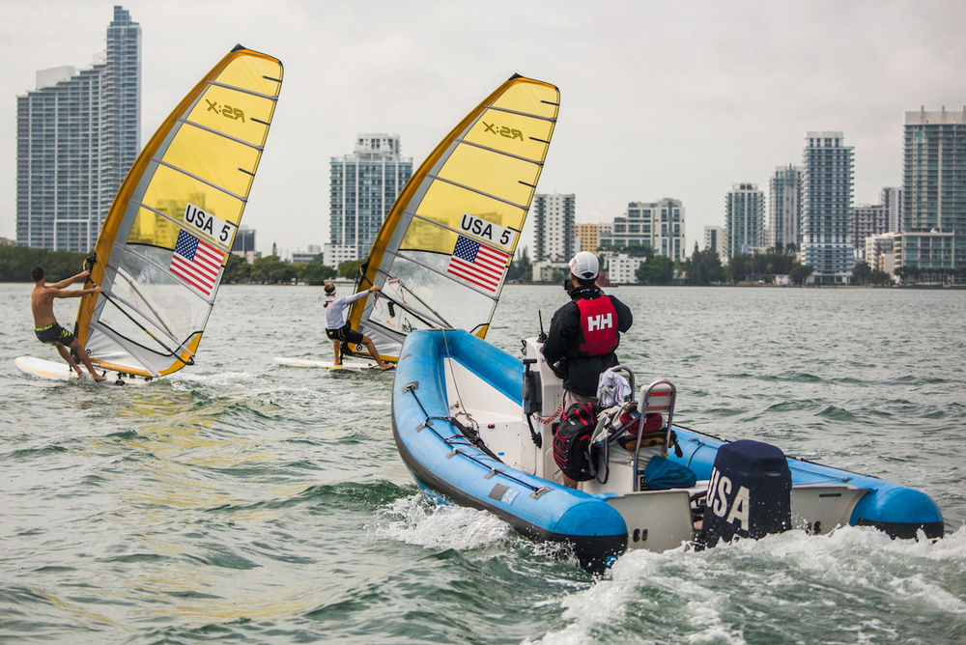
Jen Edney
Any person acting in support of a competitor is now bound by the rules and may be penalized for breaking a rule.
In this, the fourth in a series of articles on the changes in new rules, the focus is on penalties. There are changes that increase the times during which boats may be penalized for breaking certain rules, changes in the penalty given, and new rules that permit penalizing “support persons,” including coaches and parents.

When Penalties May Be Given
Let’s start with a hypothetical scenario: Six minutes before the start of the first race of a series for a big fleet of large keelboats, you are in the racing area, intending to race, and on starboard tack reaching below the starting line well clear of Reckless, which is on port tack on a course to pass to leeward of you. Without warning, Reckless luffs up and T-bones you amidships, causing only superficial damage to her bow but major damage to your hull. The damage forces you to motor back to the harbor and prevents you from sailing any race of the series.
Under the second sentence of the preamble to Part 2 in last year’s rules, even though Reckless broke Rules 10 and 14, she could not be penalized because she was not racing at the time of the incident. Reckless went on to sail and win the first race of the series.
That sure doesn’t sound fair. The outcome this year would be different. The second sentence of the preamble to the Part 2 rules now reads, “...a boat not racing shall not be penalized for breaking one of these rules, except rule 14 when the incident resulted in injury or serious damage...” So now, Reckless would be disqualified for breaking Rule 14 even though she was not racing when she broke it. Under the new preamble, Reckless would also have been penalized if, after finishing while still “in or near the racing area,” she had broken Rule 14 and caused injury or serious damage. Previously, if the incident had occurred while you and Reckless were racing and the race had later been abandoned, Reckless would not have been penalized. However, Rule 36 has been changed such that now she would be penalized [see new Rule 36(b)]. To sum up, now whenever a boat breaks Rule 14 while the Part 2 rules apply, they will be penalized if they cause injury or serious damage.

Changes in the Penalties Given
Under last year’s rules, with only two exceptions, if you were protested and the protest committee found you had broken a rule, the penalty was always disqualification. The exceptions were Rules 69 and 77. Under the new rules, if a boat breaks Rule 2, Fair Sailing, the penalty may be either a DSQ or a disqualification that is not excludable (DNE). In addition, World Sailing race officials now often label certain rules in the notice of race or sailing instructions with the letters “DP” for “discretionary penalty. If a boat breaks a rule labeled “DP,” the penalty may, at the discretion of the protest committee, be less than disqualification [see the new paragraph in the Introduction called “Notation”].
Examples of sailing instructions that are frequently designated “DP” at World Sailing events are Check-Out and Check-In Requirements (SI 18 in Appendix L), Replacement of Crew or Equipment (SI 19), Haul-Out Restrictions (SI 25) and Limitations on Electronic Communication (SI 27). The new rule book has two rules for which the penalty is “DP” — Rule 55, Trash Disposal, and Rule 77, Identification on Sails [see Rule G4 in Appendix G.]

Penalties for Support Persons
The new rules now contain provisions that require “support persons” to “accept the rules.” These rules were written by a World Sailing committee consisting of lawyers, race officials and members of the World Sailing Racing Rules Committee. This is a development in response to the many support boats that come to regattas with coaches or, in the case of youth sailors, parents to provide support. To help you understand these significant changes, I’ll take you on a guided tour through your new rule book of the changes in definitions and rules that relate to support persons. Our first stop is at the new definition “Support Person.”
Support Person: Any person who (a) provides, or may provide, physical or advisory support to a competitor, including any coach, trainer, manager, team staff, medic, paramedic or any other person working with, treating, or assisting a competitor in or preparing for the competition, or (b) is the parent or guardian of a competitor.
Our next stop is Rule 3, Acceptance of the Rules. This is the rule that the lawyers refer to as “the hook.” Each competitor and boat owner is “hooked” by the following words in Rule 3: “By participating or intending to participate in a race conducted under these rules, each competitor and boat owner agrees...to be governed by the rules, to accept the penalties imposed...under the rules,” and not resort to a court with respect to any decision made by race officials under the rules.
Rule 3 is now extended to include similar provisions that apply to support persons. These state: “A support person by providing support, or a parent or guardian by permitting their child to enter a race,” agrees to be hooked into the same agreement as the one quoted above for competitors and boat owners. In addition, Rule 3 requires “each competitor and boat owner to ensure that their support persons are aware of the rules.” On the next portion of our guided tour, it would be logical for me to point out the rules a support person must follow. You might be surprised to learn that there are only three rarely used rules that state that a support person shall or shall not do something; they are Rules 6, 7 and 69.1. However, the defined term “rules” includes the rules in the notice of race (NoR) and sailing instructions (SIs), and those documents often contain rules that involve support persons, especially coaches and parents, and the boats from which they watch the races. It is those rules in the NoR or SIs and that a coach or parent is most likely to break.
The next stops on our tour are Rules 60.3(d) and 69.2. These rules explain how a support person can end up in the protest room. Suppose it’s alleged that a support person has broken a rule. A hearing to consider whether a support person has broken a rule can be instigated only by the protest committee. The protest committee can act under this rule based on its own observations or on information received “from any source, including evidence taken during a hearing.” Therefore, a competitor or race-committee member who believes that a support person has broken Rule 69.1 or a rule in the Notice of Race or Sailing Instructions should report the matter to the protest committee. If the protest committee thinks it’s appropriate, it will schedule a hearing. The support person alleged to have broken a rule will be a party to that hearing [see new paragraph (e) in the definition Party]. The person who made the allegation will not be a party to such a hearing but will surely be called as a witness to give testimony.
Our final stop brings us to new Rule 64.4. After such a hearing, if the protest committee “decides that the support person...has broken a rule,” it must follow the process set out in Rule 64.4. Unlike a boat entered in an event, a support person does not have a score to which a penalty may be assessed. Rule 64.4 gives the protest committee considerable discretion as to how to penalize a support person. The committee may warn the support person; it may exclude the support person from the event venue, or it may remove any privileges granted to support persons at the event. Competitors beware: If one of your support persons breaks a rule, your boat may be penalized by changing your boat’s score in one race, up to and including DSQ. However, your boat can be penalized only if you gained a “competitive advantage” from the support person’s breach or if “the support person commits a further breach after [you have] been warned by the protest committee that a penalty may be imposed.”

